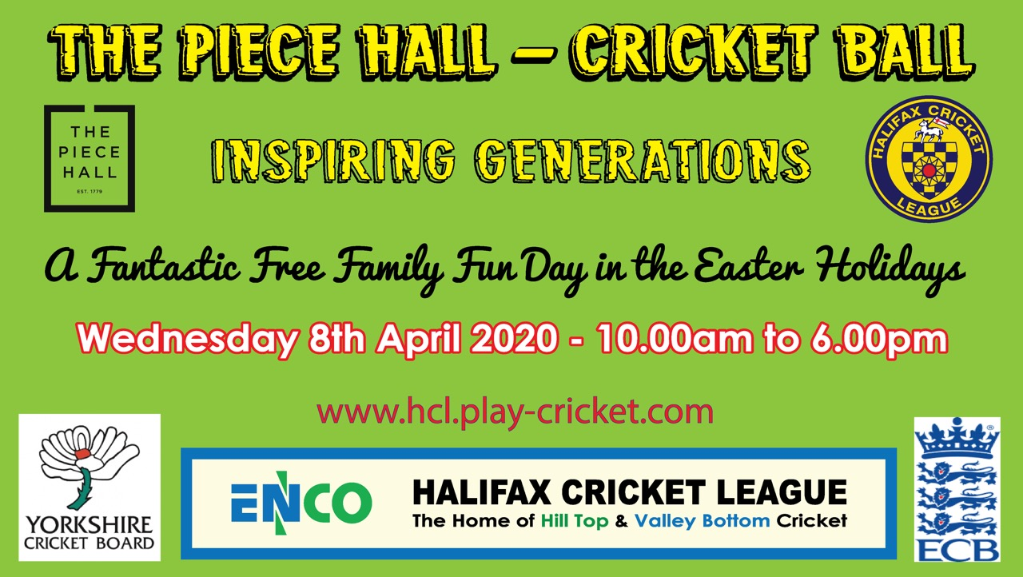

**The Halifax Cricket League** – We are a forward thinking organisation whose aim is to promote the opportunity for participation in cricket across the communities we serve: Halifax, the Calder Valley and areas of Bradford and Huddersfield. We have a thriving Saturday league of 31 clubs, a Sunday League of 26 clubs and over 80 junior teams.

**The Idea -** Participation in sport is declining and young people are becoming less active. As a league we recognised an opportunity to do something just a little bit different on the back of the thrilling world cup win last summer, Ben Stokes breathtakingly unique innings at Headingly in the Ashes and the launch of the English Cricket Board “The Hundred” competition in 2020. In Halifax we have an iconic location in the Piece Hall which hosts many big events and it was the Grand Depart and Tour De Yorkshire cycling event that provided the inspiration for our big event **“Piece Hall Cricket Ball Inspiring Generations”.**

**The Objective –** Is simple: to give people of all ages the opportunity to get involved in local league cricket either playing, officiating or volunteering at a club local to them irrespective of age, race, gender, disability or ability promoting wellbeing and healthier lifestyles!

**The Event** – Just for one day we are turning the Piece Hall courtyard into a cricket field with 3 cricket zones and a Fanzone

**Zone 1 –** **Cricket Field** **Allstars (5-7 year old) & Dynamo’s (8-11 year old)** coaching zone with batting, bowling and fielding drills run by qualified YCB coaches.

**Zone 2 –** **Cricket Cage** to create fully enclosed safe net area for youngsters to enjoy having a bat and bowl with a hard ball.

**Zone 3 –** **Interactive Skills & Drills** using fun equipment like speed guns and catching crash mats run by our league coaches in conjunction with our Cricket Coaching Partners, The Cricket Asylum Sowerby Bridge and The Cricket School, Bingley.

**Fanzone –** **Stalls and Spectator** area so people can learn about the different cricket opportunities across our region, come and see the actual World Cup Trophy or try some locally sourced cricket themed food and beverages provided by local suppliers.

**Press & PR –** The event will be publicised and marketed through all our clubs, schools, the Local Council and across West Yorkshire using the media, press, PR and social media. Radio Leeds have already committed to covering the event and BBC Look North, ITV Calendar and Sky Sports may cover the event. Yorkshire C.C are providing both current Vikings and Diamonds players to support the event and we are hopeful that the World Cup will be in attendance and perhaps even an England cricketing celebrity.

**Get Involved -** If you would like to be a part of this then please get in touch we would love to have you on board!

**Yours in cricket**